
Tribhuvan University
Faculty of Humanities and Social Sciences

College Management System

A MID DEFENSE REPORT

Submitted to
Department of Computer Application
Pascal National College

In partial fulfillment of the requirements for the Bachelors in Computer Application

Submitted By
Avi Khadka
Sakshyam Khadka

Under the Supervision of
Jagdish Bhatta

ABSTRACT
The College Management System is a web-based application developed to simplify, automate, and digitize essential academic and administrative activities within a college environment. The system provides students with secure access to academic information such as examination results, assignments, courses, examination schedules, and fee and payment details through a centralized web platform. This approach improves accessibility, transparency, and efficiency in information management.
The application follows a role-based access control mechanism where administrators can perform Create, Read, Update, and Delete (CRUD) operations to manage student records, academic data, course details, examination results, and fee structures. Students are allowed to securely view their academic and financial information. The frontend of the system is developed using React.js to provide a responsive and interactive user interface, while the backend is implemented using a MERN-based architecture with Node.js and Express.js. Data storage and management are handled using a MySQL database configured through XAMPP. Overall, the system reduces manual work, minimizes errors, and enhances communication between students and administration.

ACKNOWLEDGMENT

We would like to thank the Department of Computer Applications, Pascal National College, for giving us the opportunity to complete this project as part of the BCA 4th Semester Project (Project–I).
We are sincerely grateful to the Head of the Department (BCA), Mr. Ashok Pant, for his guidance, support, and encouragement throughout the project. We also thank Mr. Jagdish Bhatta for his valuable suggestions and motivation during the development of this project.
We would like to thank our friends and classmates for their cooperation and support. Finally, we extend our thanks to all faculty members and everyone who directly or indirectly helped us in completing this project successfully.

Table of Contents

Error: Reference source not found
3
5
6
7
7
Error: Reference source not found
Error: Reference source not found
Error: Reference source not found
Error: Reference source not found
12
Error: Reference source not found
Error: Reference source not found
Error: Reference source not found
14
15
Error: Reference source not found
Error: Reference source not found
Error: Reference source not found
Error: Reference source not found
Error: Reference source not found
Error: Reference source not found
Error: Reference source not found
26
Error: Reference source not found

LIST OF ABBREVIATIONS
CRUD : Create, Read, Update, Delete
DFD : Data Flow Diagram
ER : Entity Relationship Diagram
MERN : MongoDB, Express.js, React.js, Node.js
API : Application Programming Interface
SDLC : Software Development Life Cycle
SQL : Structured Query Language
UI : User Interface
VS Code : Visual Studio Code
XAMPP : Cross-Platform Apache MySQL PHP Perl

LIST OF FIGURES
Figure 3.1 Waterfall method College Management System
Figure 3.2 Use case diagram of College Management System
Figure 3.3 Gantt Chart
Figure 3.4 ER-Diagram of College Management system
Figure 3.5 Level 1 DFD of College Management System
Figure 3.6 Database Schema Design of College Management system
Figure 3.7 UI Design of College Management System

CHAPTER 1: INTRODUCTION

1.1 Introduction
The modern educational landscape is rapidly evolving, creating a strong demand for efficient, accurate, and reliable management of institutional data. A College Management System is a web-based software application designed to integrate and automate various academic, administrative, and student-related activities within a college environment. Traditionally, many colleges have relied on manual, paper-based systems or isolated digital tools to manage student records, staff information, course details, examinations, and fee structures. These traditional approaches are often time-consuming, labor-intensive, and highly prone to human errors.
This project proposes a centralized digital platform that streamlines the flow of information across different departments of a college. By consolidating data related to students, staff, courses, examinations, and fees into a single integrated system, the platform ensures data accuracy, consistency, and easy accessibility for authorized users. The primary objective of this system is to reduce the manual workload of administrative staff while improving transparency, efficiency, and communication within the institution.
The system provides role-based access to different stakeholders such as students and administrators. Students can securely access academic information including examination results, assignments, course details, examination schedules, and fee payment status through dedicated web pages. Administrators can efficiently manage student records, academic data, examinations, and financial information using Create, Read, Update, and Delete (CRUD) operations, along with generating reports for better decision-making.
The College Management System is developed using React.js for the frontend to provide a responsive and interactive user interface. The backend is implemented using a MERN-based architecture, utilizing Node.js and Express.js for handling server-side logic and API communication. For data storage and management, a MySQL relational database is used and configured through XAMPP, ensuring secure and structured data handling.

1.2 Problem Statement
Despite significant technological advancements in various sectors, many educational institutions continue to rely on outdated and inefficient management practices. Most colleges still depend on manual documentation, paper-based records, or scattered digital files to manage academic and administrative data. This traditional approach creates several critical challenges that affect the overall efficiency and effectiveness of institutional operations.
Inefficiency and Manual Workload:
Managing large volumes of data such as student registrations, attendance records, examination details, and fee information manually requires considerable time and human effort. These repetitive tasks increase the administrative workload and reduce operational efficiency.
Data Fragmentation and Inaccuracy:
When data is stored across multiple physical files or unconnected digital systems, maintaining consistency becomes difficult. The absence of a centralized database often leads to duplication of records, data inconsistencies, and increased chances of errors, resulting in delayed information retrieval.
Lack of Effective Communication:
Without a unified digital platform, communication between administrators, staff, and students is often slow and inconsistent. Important announcements related to examinations, schedules, results, and fees may not reach stakeholders on time, causing confusion and dissatisfaction.
Inadequate Reporting and Analysis:
Manual systems make it difficult to generate accurate and timely reports required for academic evaluation and administrative decision-making. Collecting and compiling data from multiple sources is time-consuming and prone to errors, limiting the ability to analyze institutional performance effectively.

1.3 Objectives
The main objectives of the College Management System are:
- To automate academic and administrative processes
- To reduce manual workload and errors
- To provide secure access to student information
- To improve communication between students and administration
- To centralize academic data management

1.4 Scope and Limitation
Every software system has its own features as well as certain limitations. The scope of a project defines its boundaries and the specific functionalities that the system is designed to perform. The scope and limitations of the proposed College Management System are described below.

Scope
The College Management System focuses on automating and managing essential academic and administrative activities within a college environment. The scope of the system includes:
- Centralized Data Management:
The system provides a centralized platform for storing and managing information related to students, courses, examinations, and fees using a secure MySQL database.
- Modular and Role-Based Access:
The system is divided into different modules based on user roles to ensure secure and organized access:
  - Student Module: Enables students to view academic details such as course information, examination schedules, results, assignments, and fee payment status.
  - Admin Module: Provides administrative control for managing students, courses, examinations, fees, and generating reports using CRUD operations.
  - Exam Module: Manages examination schedules, result publication, and performance analysis.
- User-Friendly Interface:
The frontend of the system is developed using React.js, providing a responsive, interactive, and easy-to-use interface for all users.
- Web-Based Accessibility:
The system can be accessed through a web browser, allowing authorized users to use the application from different locations.

`Limitations
Despite its advantages, the system has certain limitations:
- Internet Dependency:
As the system is web-based, a stable internet connection is required for proper functionality. Limited or no internet access may restrict system usage.
- Hardware Dependency:
System performance depends on server capacity and the user’s device such as a desktop or laptop.
- Limited Automation for Legacy Data:
Initial data entry for existing records may require manual input during system setup.
- Platform Limitation:
The current system is designed for web platforms only and may require additional development for mobile application support.

1.5 Report Organization
The report entitled “College Management System” is organized into six chapters, each focusing on different aspects of the system development process. The structure of the report is described below:
Chapter 1: Introduction
This chapter provides a brief overview of the project. It includes the introduction, problem statement, objectives, scope and limitations, and the overall organization of the report.
Chapter 2: Background Study and Literature Review
This chapter discusses the background of the existing system and reviews related studies and existing systems. It highlights their features, advantages, and limitations, providing a foundation for the proposed system.
Chapter 3: System Analysis and Design
This chapter explains how the system is analyzed and designed. It includes functional and non-functional requirements, system architecture, feasibility analysis, and design diagrams such as DFD and ER diagrams that describe system behavior and data flow.
Chapter 4: Implementation and Testing
This chapter presents the implementation details of the system, including the tools and technologies used. It also discusses the testing and debugging processes carried out to ensure system reliability and correctness.
Chapter 5: Expected Outcomes
This chapter describes the expected results and benefits of implementing the College Management System, including improvements in efficiency, accuracy, and accessibility.
Chapter 6: Conclusion and Future Enhancement
This chapter summarizes the overall project and discusses possible future enhancements and improvements to the system.

CHAPTER 2: BACKGROUND STUDY AND LITERATURE REVIEW

2.1 Background Study
The concept of a College Management System arises from the ongoing challenges faced by educational institutions in managing large volumes of academic and administrative data. Traditionally, colleges have depended on manual data entry, paper-based records, and basic spreadsheet applications to maintain student information, staff details, course records, examination data, and fee structures. These traditional methods are inefficient, time-consuming, and highly prone to errors, making data retrieval and management a difficult task.
With the rapid growth of information technology in the education sector, there is an increasing demand for centralized and automated systems capable of handling complex administrative tasks such as student registration, attendance management, examination scheduling, result processing, and fee management in real time. Manual systems lack scalability, accuracy, and transparency, which often leads to data inconsistency and poor communication between departments.
This project aims to bridge the gap between outdated manual practices and modern digital solutions by introducing a web-based College Management System. The proposed system provides a centralized platform that enhances institutional efficiency, improves data accuracy, reduces administrative workload, and ensures seamless access to information for authorized users.

2.2 Literature Review
Current research and existing systems in the field of educational management highlight both progress and areas for improvement:
- Existing Digital Solutions: Many educational institutions have started using management software to handle administrative tasks digitally. These solutions have shown that digital systems can improve operational efficiency, speed up data handling, and provide a reliable framework for storing and retrieving information. Modern web-based systems, especially those using frameworks like React, allow for dynamic and responsive interfaces for students and admin.
- Inefficiencies in Current Systems: Despite the adoption of some digital tools, many institutions still rely on manual or semi-automated processes. Studies indicate that fragmented systems can cause delays, make tracking student information difficult, and reduce overall efficiency. Fully integrated systems are necessary to overcome these challenges and provide seamless administrative management.
- Benefits of Centralization: Literature emphasizes that centralized educational management systems act as a “single source of truth,” consolidating information to reduce redundancy and errors. Such systems improve communication between administrators, faculty, and students, enabling faster decision-making and accurate reporting. A centralized approach also makes maintenance and data security easier.
- Technological Trends: Modern systems increasingly use the MERN stack (MongoDB, Express, React, Node.js) for their backend and frontend capabilities, but in some cases, relational databases like MySQL are preferred for structured data storage, as it provides reliable query handling and integration with tools like XAMPP. Technologies like React enhance user experience, while Node.js and Express handle server-side operations efficiently, making the system scalable and maintainable.

CHAPTER 3: SYSTEM ANALYSIS AND DESIGN

3.1 System Analysis
The Requirements for this project are all known and there is very less time for the development so, waterfall model fits perfectly for developing this project. The project is divided into the six phases i.e., Requirement Analysis, System Design, Implementation, Testing and Deployment.
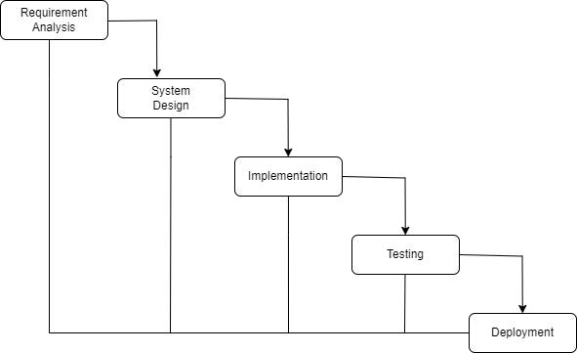

Figure 3.1 Waterfall method College Management System

3.1.1 Required Analysis
I. Functional Requirement
Student Module
- Student registration and profile creation
- Attendance tracking and viewing
- Grade and academic result viewing
Admin Module
- Overall student and course management
- Automated report generation and analytics
- System-wide notifications and announcements
Exam Module
- Examination scheduling
- Result processing and publishing
- Student performance trend analysis
General System Functions
- Centralized data storage in MySQL
- Secure user authentication and login
- Administrative decision support through data reporting
II. Non-Functional Requirement
• Security
• Accuracy
• Efficiency
• Reliability
• Usability

3.1.2 Feasibility Analysis
The feasibility study for the College Management System ensures that the project is technically achievable, financially practical, and operationally effective before full-scale development.

Technical Feasibility
- The system uses a modern and reliable technology stack, including React for the frontend, Node.js and Express for the backend, and MySQL as the database through XAMPP.
- These technologies are compatible and provide the necessary tools to handle student, staff, and admin modules efficiently.
- The stack supports scalability, security, and responsive user interfaces, ensuring smooth performance for concurrent users.

Economic Feasibility
- The project is cost-effective since it leverages open-source technologies like React, Node.js, Express, and MySQL, which do not require expensive licensing fees.
- By automating administrative tasks, the system reduces manual labor and saves long-term costs related to paper records, administrative staff, and error correction.
- The use of XAMPP allows local development and testing without additional infrastructure costs.

Operational Feasibility
- The system is designed with an intuitive, user-friendly interface, enabling students, staff, and management to navigate easily.
- It addresses real-world problems by centralizing data, improving communication, and reducing administrative delays, leading to higher acceptance among stakeholders.
- Implementation includes a User Training phase to ensure all users can operate the system effectively.

Schedule Feasibility
- The project follows a structured Waterfall Model, with clear timelines for requirement analysis, design, development, and testing.

The interactions between different users and the College Management System are illustrated below using a use case diagram
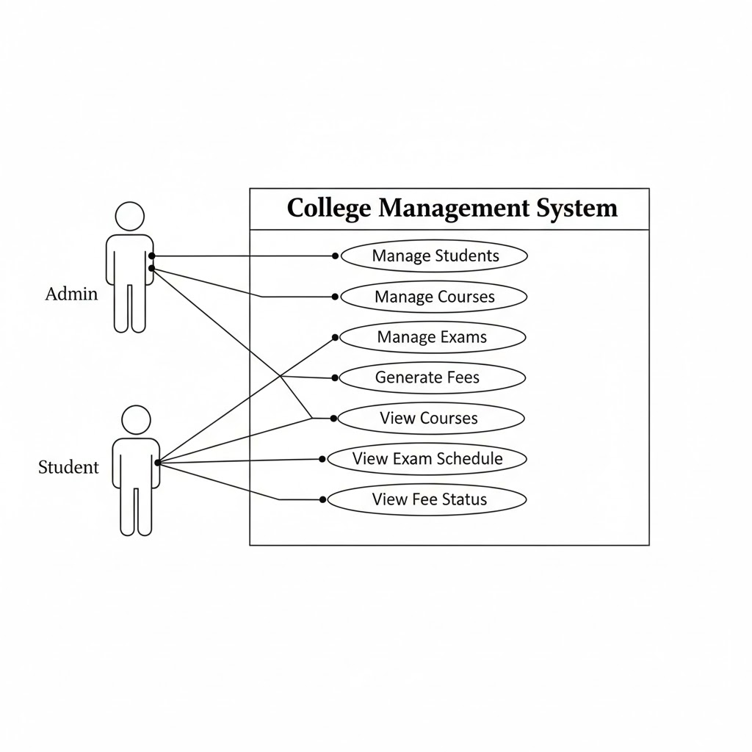

figure :3.2 USE CASE DIAGRAM
The Use Case Diagram of the College Management System represents the functional requirements and interactions between the system and its users. The diagram identifies the key actors, including students, teachers, and administrators, and maps out their interactions with the system through various use cases. Core functionalities such as student registration, course management, attendance tracking, grading, and report generation are captured as use cases. The diagram provides a clear overview of the system’s intended behavior, highlighting which users perform specific actions and how the system responds. This helps in understanding the scope of the system, ensuring proper design, and guiding subsequent development and testing phases.

The time schedule of the different parts of the project can be seen below in the following Gantt chart.

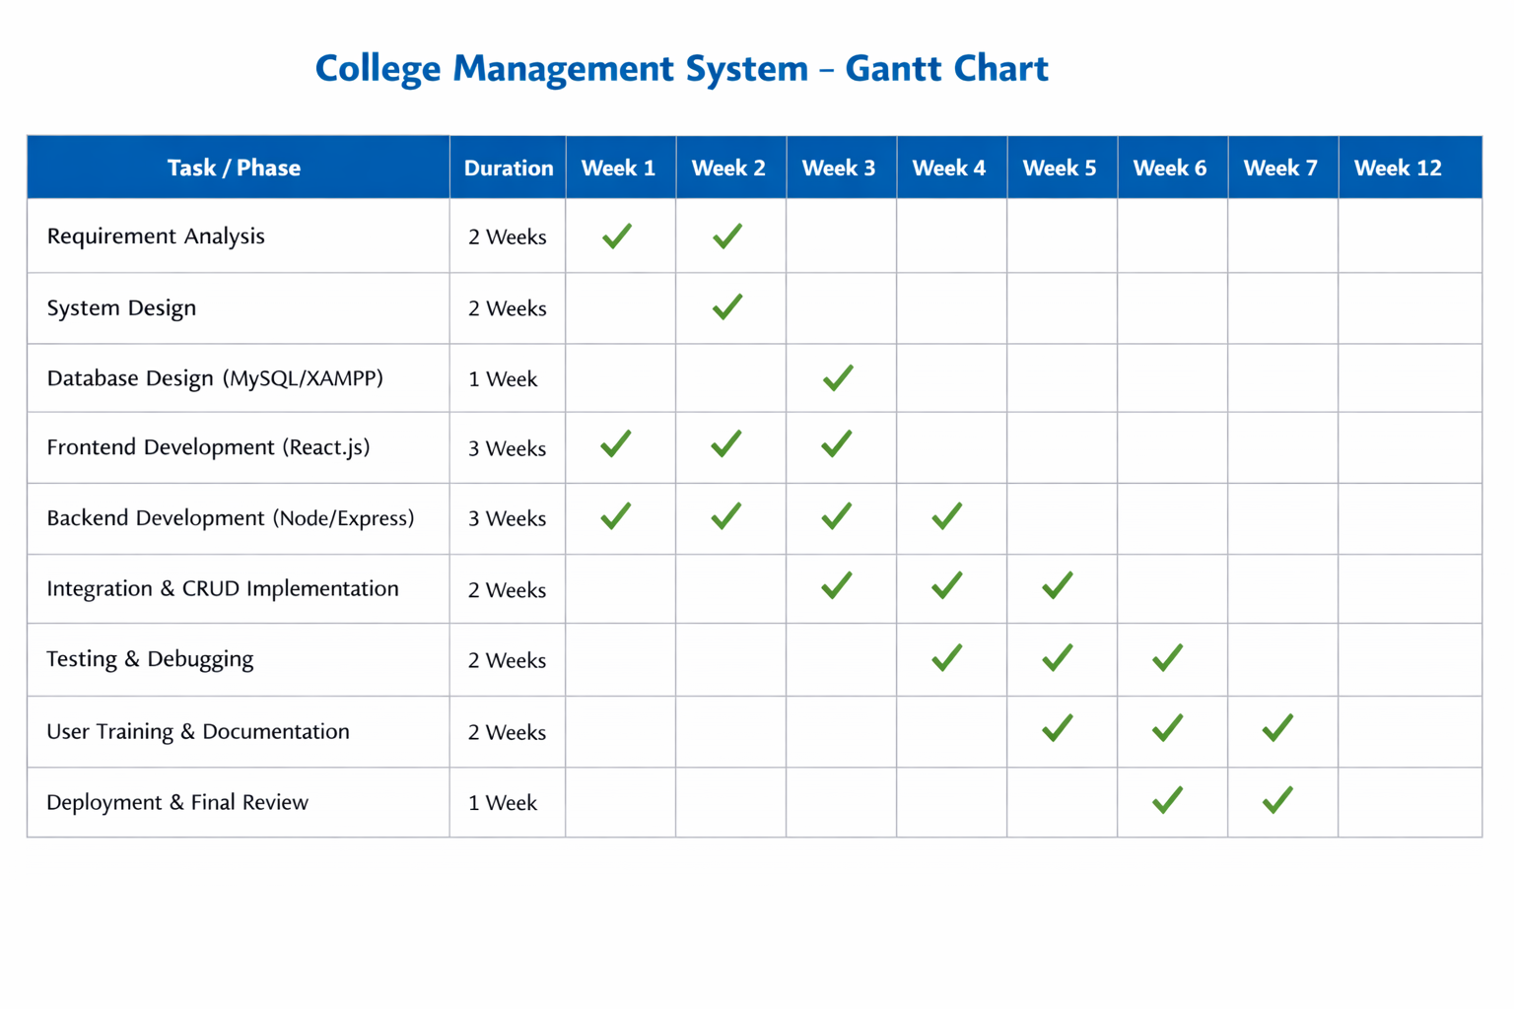

Figure 3.3 Gantt Chart
The Gantt chart of the College Management System project is shown in the above figure. The chart represents the project plan for a duration of four months. This project follows the Waterfall Model, and the tasks are organized sequentially according to its phases. The project begins with requirement gathering and moves through system design, database setup, frontend and backend development, integration, testing, and deployment. A significant portion of the timeline is allocated to coding and implementation, while documentation is maintained continuously from the start to the end of the project to ensure proper record-keeping and facilitate future maintenance.

The entity-relationship model of the system, illustrating the logical structure of the database and the connectivity between students, courses, and financial records, is shown below.
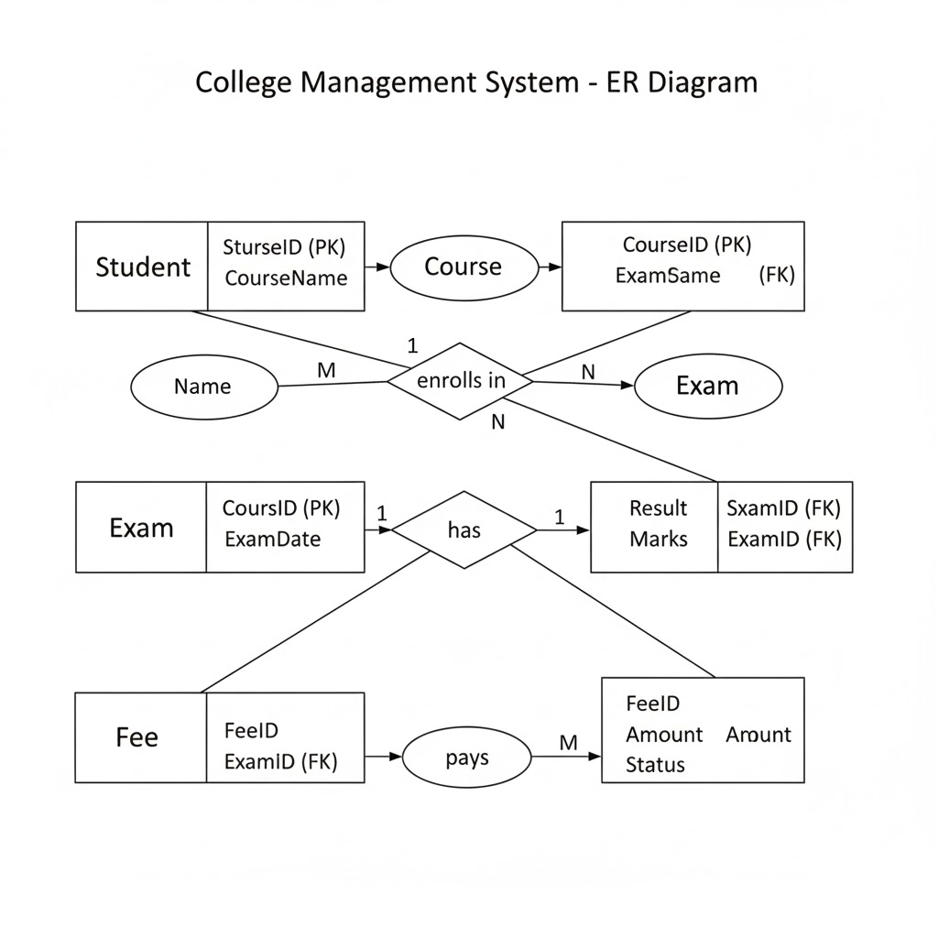
Figure 3.4 Er diagram for College Management System

The Entity Relationship (ER) Diagram of the College Management System is shown in the figure below. The diagram illustrates the logical database structure, showing how entities like Student, Course, Exam, Result, and Fee interact through defined relationships. Each entity includes specific attributes and primary keys to ensure data integrity and organized information management within the system.

The Level 1 Data Flow Diagram (DFD) expands the context diagram and shows the major processes of the College Management System along with their interactions with external entities and data stores.
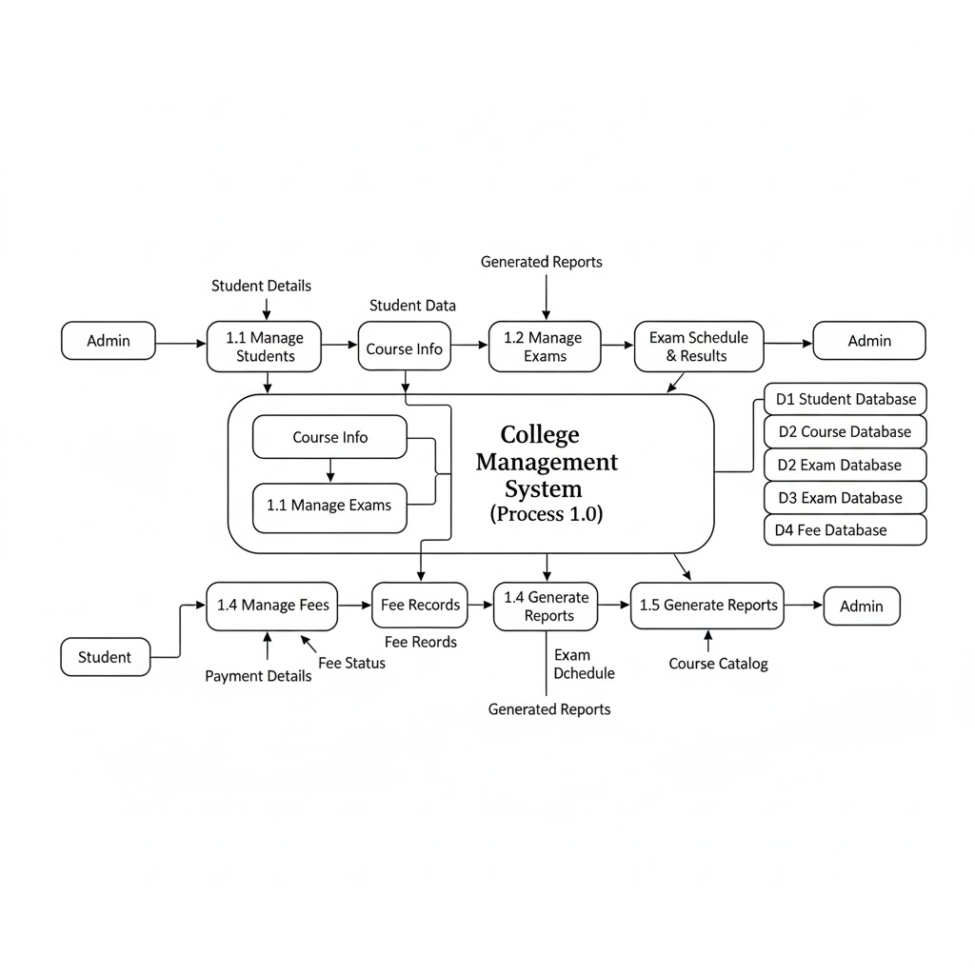
Figure 3.5 Level 1 DFD of College Management System
The Level 1 Data Flow Diagram of the College Management System shows the flow of data between students, administrators, and major system processes such as student management, course management, examination and result management, and fee management. It also includes data stores like student records, course details, result records, and fee records, demonstrating how information is processed and stored to support academic and administrative activities.
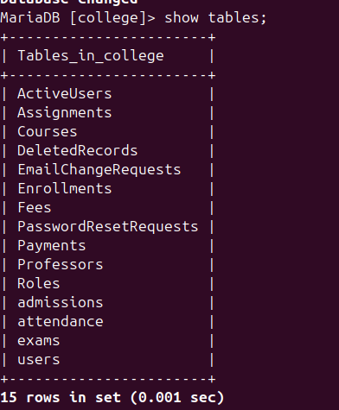
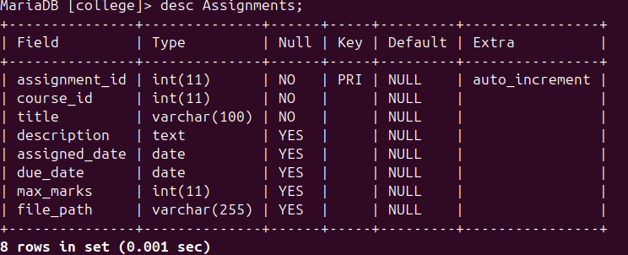

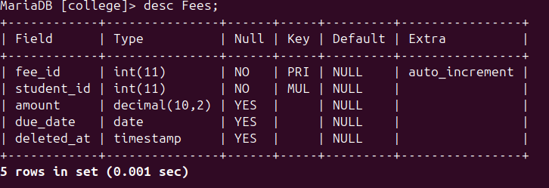

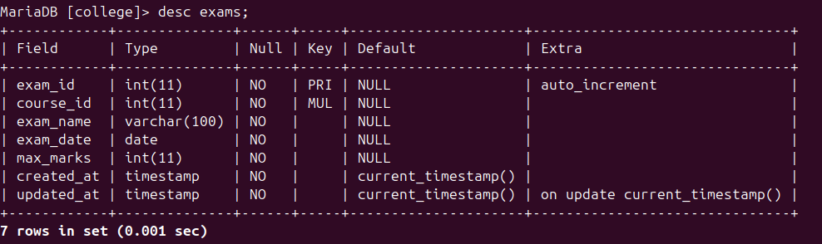
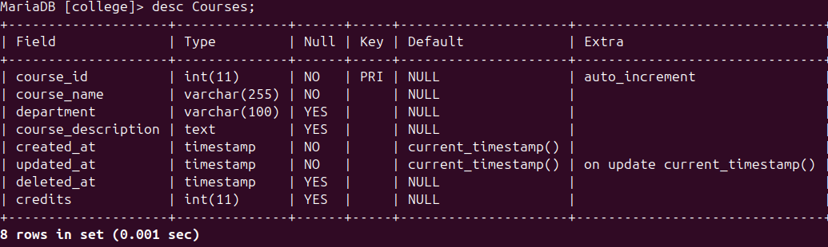

Figure 3.6 Database Schema Design of College Management system
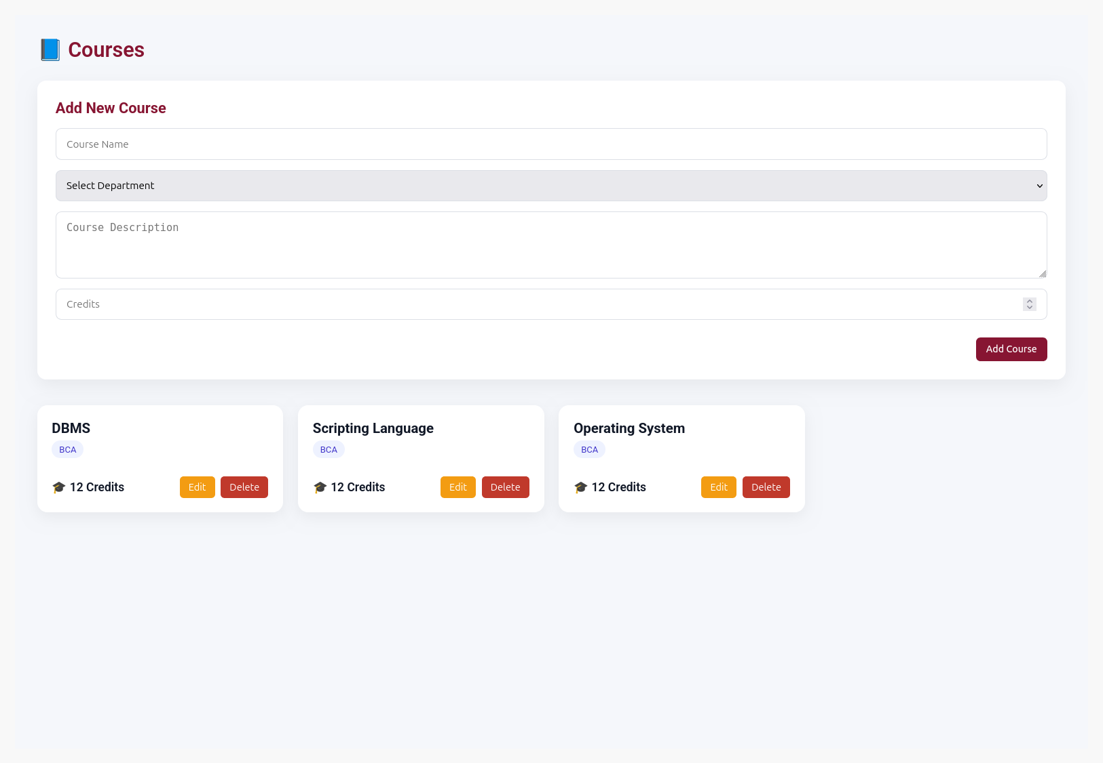
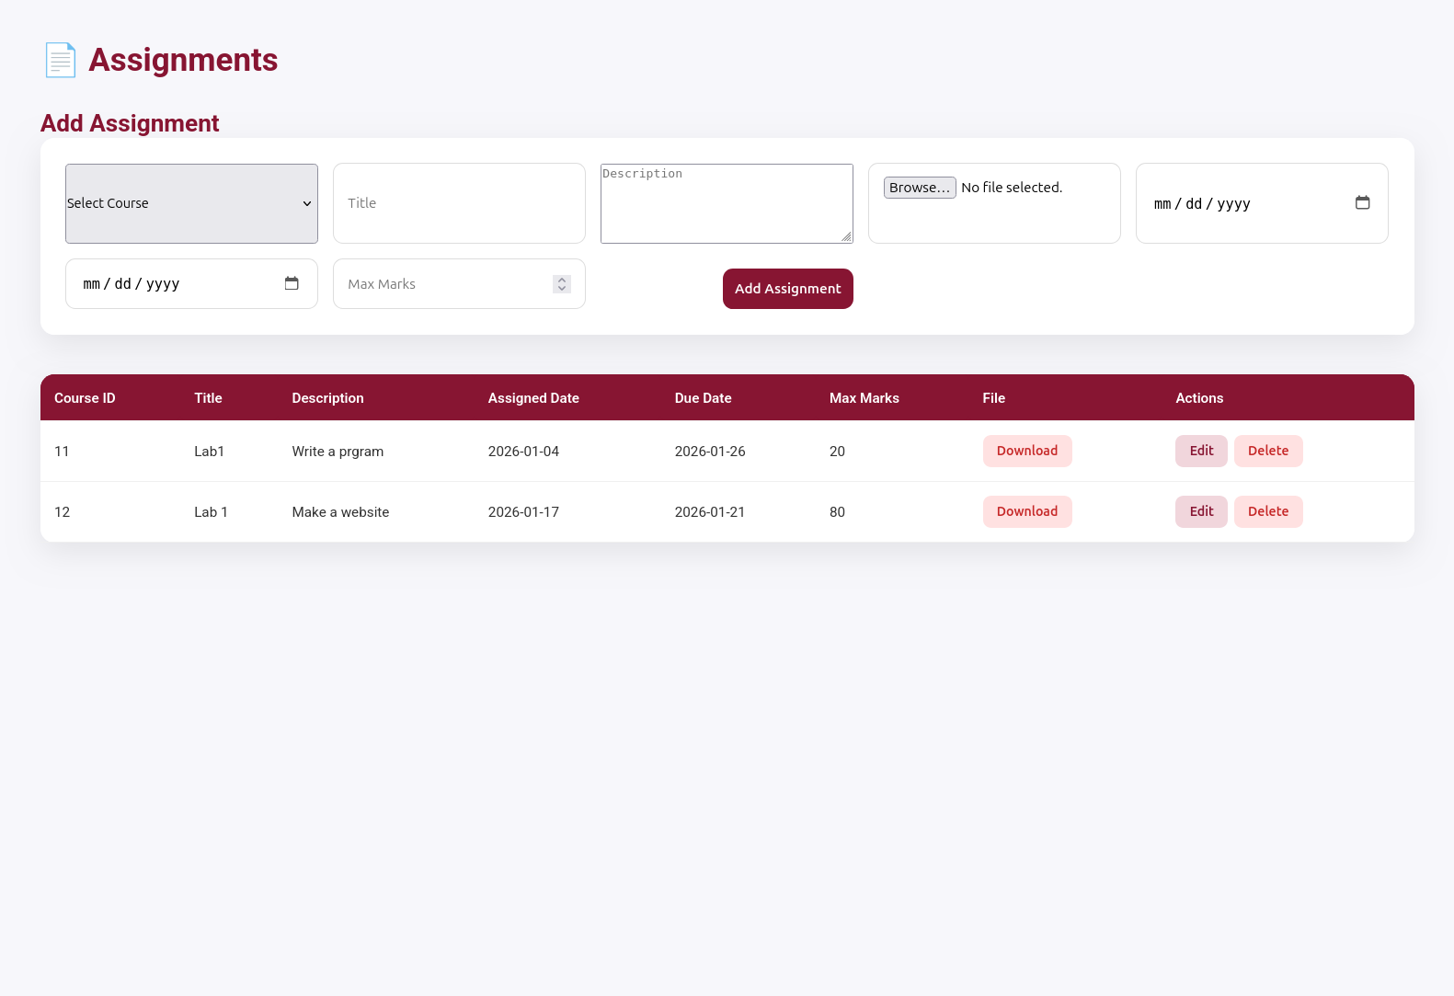
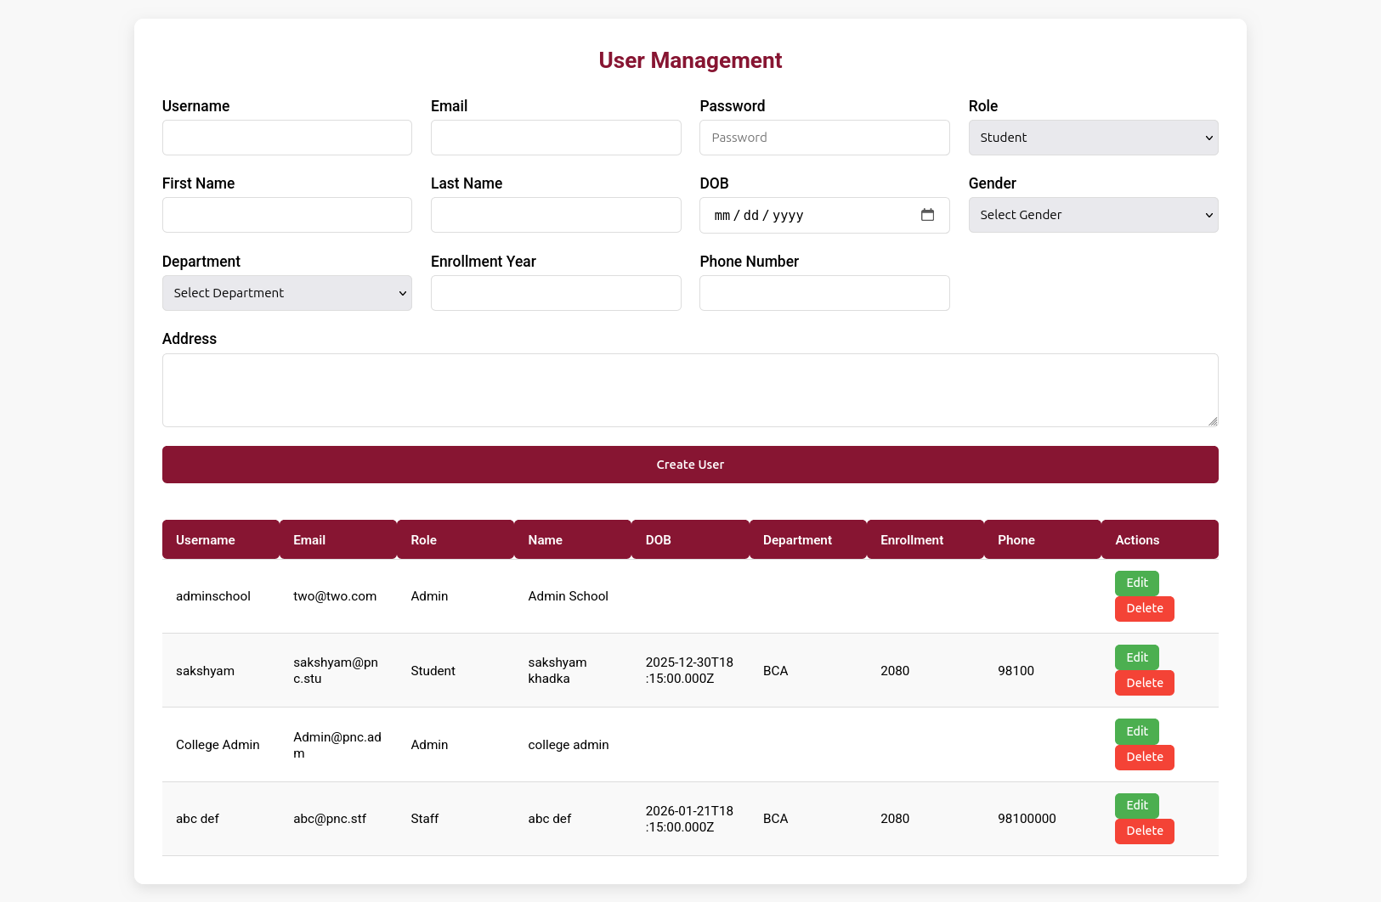

Figure 3.7 UI Design of College Management System

CHAPTER 4: IMPLEMENTATION AND TESTING

4.1 Implementation
Implementation is the phase where the system is developed and made operational for users. During this phase, all information gathered during requirement analysis is carefully studied, analyzed, and transformed into a functional system. It is one of the most critical phases of any project, as it converts system design specifications into working software.
The implementation process typically includes coding, testing, installation, documentation, training, and support. For the College Management System, a combination of modern tools and technologies has been used to ensure efficiency, scalability, and a user-friendly experience.

4.1.1 Tools and Technology
The tools and technologies used for developing both the frontend and backend of the College Management System are listed below:
Frontend:
- React.js: A JavaScript library for building responsive and interactive user interfaces. It allows dynamic updates without reloading the page.
- HTML5 (HyperText Markup Language): Used to structure the content of web pages.
- CSS3 (Cascading Style Sheets): Used to style web pages, ensuring a clean and responsive interface.
- Figma: A browser-based web design tool used to create interactive UI prototypes and collaborate on design tasks.
Backend:
- Node.js: A JavaScript runtime environment used for building fast and scalable server-side applications.
- Express.js: A framework for Node.js that simplifies server-side development and routing.
Database:
- MySQL (via XAMPP): A relational database management system used to store and manage structured data such as student records, courses, exams, and fees.
Development and Design Tools:
- Visual Studio Code: The primary code editor used for both frontend and backend development.
- Postman: Used to test API endpoints and debug backend services.
- Git: A version control system to track code changes and manage collaboration.
- Draw.io: Used to design system diagrams, including Data Flow Diagrams (DFDs) for the project.
This combination of technologies and tools ensures that the system is robust, scalable, maintainable, and user-friendly, fulfilling the administrative and academic requirements of the college effectively.

Chapter 5. Conclusion and Future Enhancement
Conclusion:
The College Management System developed in this project successfully automates and digitizes the key academic and administrative operations of a college. By centralizing student, staff, and administrative data, the system improves efficiency, reduces manual errors, and enhances communication between students and the administration. The use of modern technologies such as React.js for the frontend, Node.js/Express for the backend, and MySQL for the database ensures that the system is scalable, robust, and user-friendly. Overall, the project demonstrates that a web-based management system can significantly streamline academic operations while providing secure access to essential information.
Future Enhancements:
Although the system meets the current requirements, several enhancements can be considered to further improve functionality and user experience:
- Mobile Application: Developing a mobile version of the system for Android and iOS to provide students and staff with on-the-go access.
- Cloud Deployment: Hosting the system on a cloud platform to enable remote access and improve scalability.
- Integration with Payment Gateways: Adding secure online payment features to allow students to pay fees directly through the system.
- Automated Notifications: Implementing email and SMS notifications for important events such as exam schedules, fee deadlines, and assignment submissions.
- Advanced Analytics: Adding reporting and analytics modules to provide insights on student performance, attendance, and resource utilization.
- Role-Based Enhancements: Expanding role-based access to allow additional functionalities for teachers, department heads, or administrative staff.
By implementing these enhancements, the system can evolve into a fully comprehensive college management platform capable of supporting a wider range of academic and administrative processes efficiently.

Chapter 6 :References
- Vidanagamage, T., Piyadali, P. P., Dilrukshi, M. G. S., Romeshika, H. D. S., & Cooray, D. (2022). Development of Student Management System. International Journal of Engineering and Management Research, 12(6), 100–109. This paper discusses the development of a web-based student management system using Node.js, React.js, and MongoDB, highlighting workflow and design considerations for educational applications.
- Piyumantha, H. P. A. H. P., Prabhash, D. V. S., Weerasinghe, T. K., Weerasiri, R. T. K., De Silva, D. I., & Dias, S. M. D. T. H. (2022). Learning Management System Built Using the MERN Stack. International Journal of Engineering and Management Research, 12(6), 149–155. This research covers the use of MERN stack technologies in building an educational web application, focusing on interactive features and backend integration.

